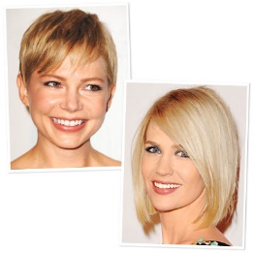
Find Your Hair Color ID: Fair Skin
"The lighter your skin tone, the paler you can go with your hair," says celebrity colorist Rita Hazan, who works with Jessica Simpson. Warm tones like Michelle Williams' look best against hues of butterscotch, strawberry blond, and honey. These shades play up the peachiness of your complexion and cast a soft glow on your face. If you have a cool skin tone like January Jones, look for blue-based colors like platinum, flaxen, and champagne blond to flatter your ivory complexion.

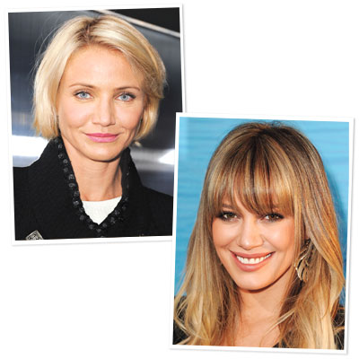
Find Your Hair Color ID : Medium Skin
Not only can this versatile complexion carry a wide spectrum of shades, but it also provides a beautiful backdrop for high-contrast highlights. People with cool skin like Cameron Diaz should stick to ashy tones like sand, wheat blond, or walnut brown to counteract any hint of ruddiness in your complexion. Tawny blond, golden caramel, or copper pick up the buttery tones and prevent sallowness in warm skin like Hilary Duff's.

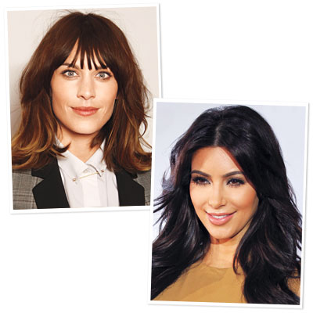
Olive skin can stand up to the intensity of a deep, rich brown, or an earthy color. "Add some strategically placed highlights in a subtle gold or honey if you want to create depth," suggests Robinson. To balance greenish undertones in cool complexions like Alex Chung's, try toasty hues like chestnut brown, auburn, and cinnamon. Ebony brown, mocha, and violet-based colors will enhance the natural warmth of tones like Kim Kardashian's.

Find Your Hair Color ID: Light Brown Skin

Linda K. says if you have warm skin tone like Kerry Washington, dark chocolate brown, medium-light golden blonde hair, light orange copper, toffee colored hair would complement your skin like you were born with it.

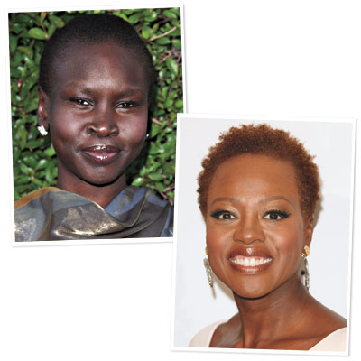
The whole idea here is to create contrast between your hair and your complexion—whether that means going lighter or darker, explains Dorram. "If your hair color is too close to your skin tone, your features will disappear." Deep, dark tones of espresso and inky black look striking next to blue-based complexions like Alek Wek's. If you have warm skin like Viola Davis, opt for maple brown, mahogany, toffee, and other rich, warm colors to bring out the apricot undertones in your skin.

